**Section 0 – Intro Page – Explains dynamics of the product (i.e. bye weeks don’t matter)**

**SECTION 1 - INPUT**

1. The first thing that must be done is that we need to figure out how to scrape projections from other sites.

Link 1 – GitHub depository that FFA uses to store their projections. The problem is that they use “R” software instead of excel to analyze them.

<https://github.com/dadrivr/FantasyFootballAnalyticsR>

Link 2 – FFA Tutorial on how to use it. I cannot figure it out. See if you can

<http://fantasyfootballanalytics.net/2016/06/ffanalytics-r-package-fantasy-football-data-analysis.html>

Link 3 – FFA blog on why R is better than excel

<http://fantasyfootballanalytics.net/2014/01/why-r-is-better-than-excel.html>

1. Enter General Settings
   1. Season should always default to current season. That’s all we need to work with for now. Weekly projections are much more valuable. I’m not sure what sites publish them.
   2. IDP (Individual Defensive Players) are not what we are worried about now. We can expand to them in the future. Deselect or do not make that an option at this point.
   3. ADP is only useful for snake drafts and you want to make sure that you are comparing apples to apples by having the ADP of the type of league you are drafting
   4. Once we can scrape projections then we can weight their historical accuracy. We should do this ourselves and not make it user input

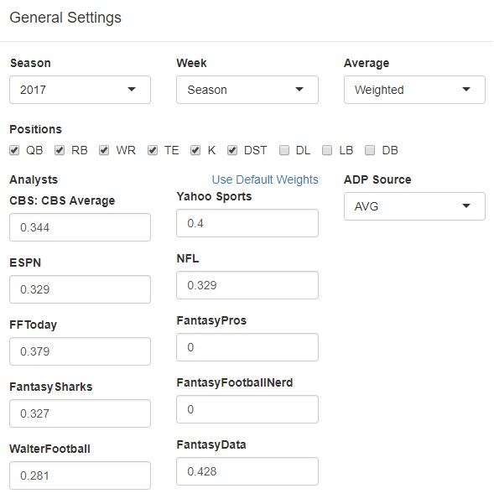

1. Enter League Settings
   1. Number of teams: 8, 10, 12 for now
   2. Roster Size can just be changed to Bench and included in the “Starter by Position” section.
   3. League scoring is basically just an autofill for everything. You should be able to save settings (We can expand to this later)
   4. VOR (Value over Replacement) Baseline is one of the most important features of our product. We will automatically fill this. The user should not input anything, but should be able to see the VOR Basline after they input scoring settings. If you want I can explain to you the concept of what VOR is and why you want to draft based on this value and not a players projected total points.
   5. # of Starters – User selects how many of each position/flex position their league requires.

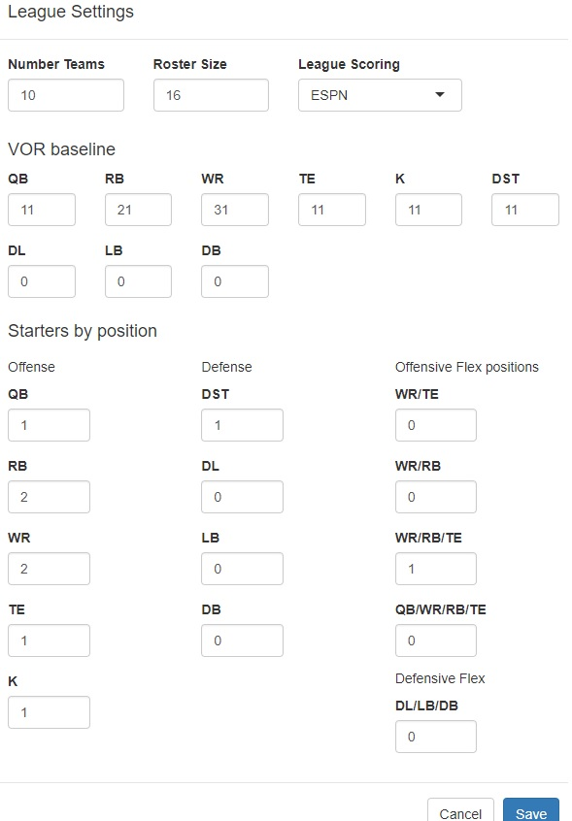

1. Scoring Settings – All on one screen preferably
   1. User inputs the points awarded for each scoring setting. We need to make sure there are projections for each awarded points so that we can have a projected score.
   2. Notice that there is a check box for “Different Scoring by position,” which means different positions get different points for the same action. (i.e. a RB gets 1 point for a reception, while a WR gets 0.5)

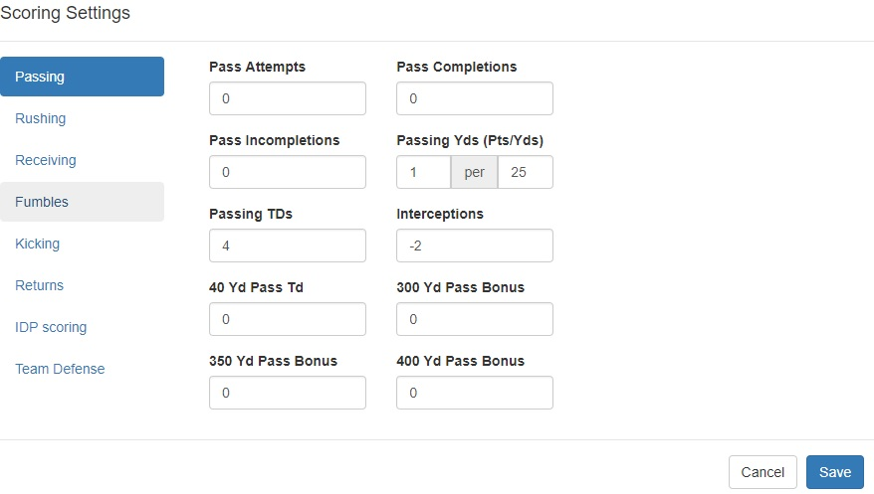

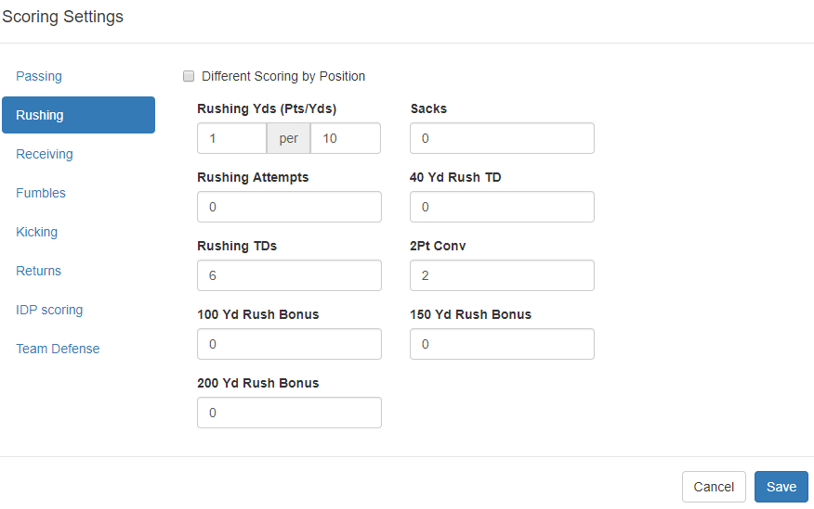

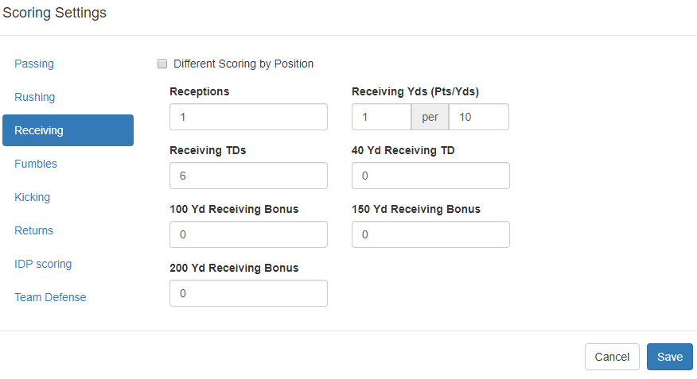

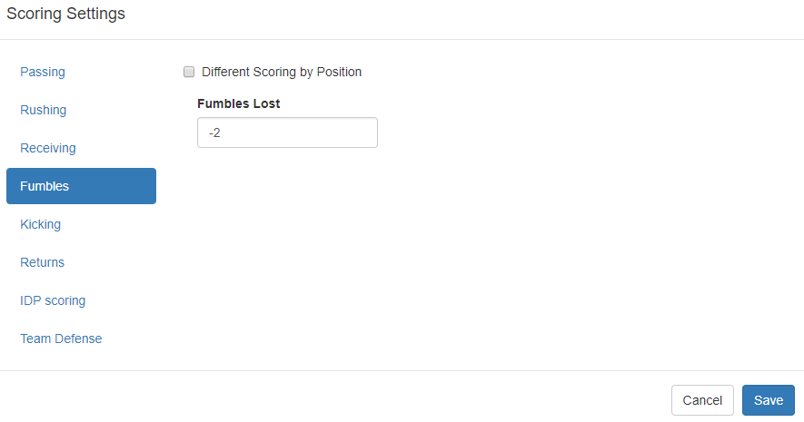

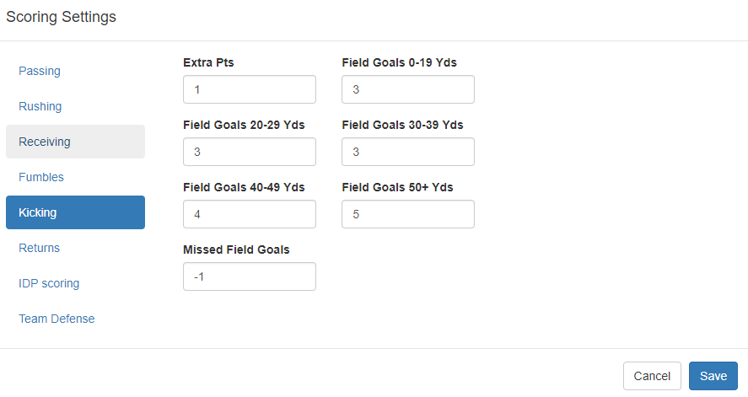

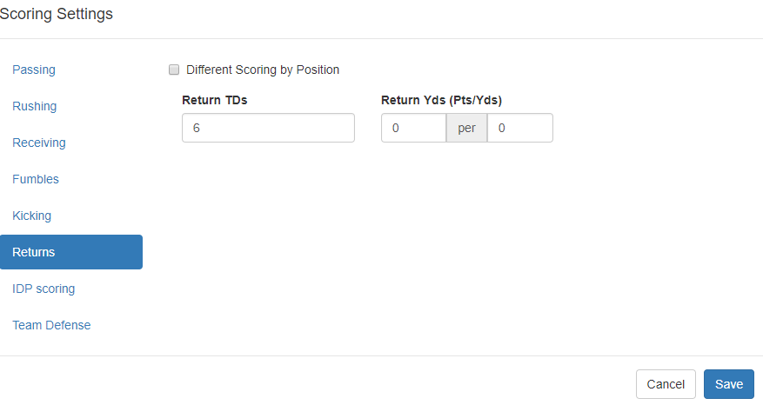

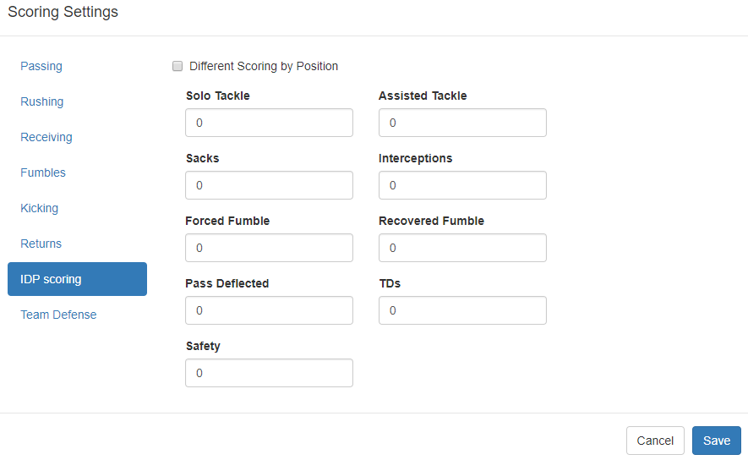

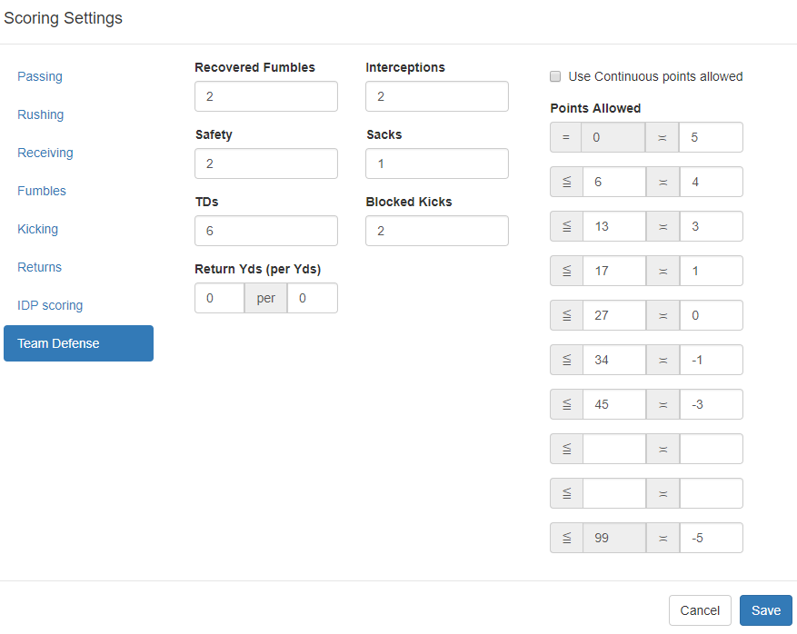

1. Auction Settings
   1. This comes up if a user has Auction Draft selected.
   2. I am not worried about the high rank/low rank/and cost multipliers. Those basically apply a 110% value to players in the players that are with the high rank threshold or Top 30 players. And 90% value to players ranking below the top 90.
   3. AAV (Average Auction Value) needs to be pulled from the website or league the user chooses.

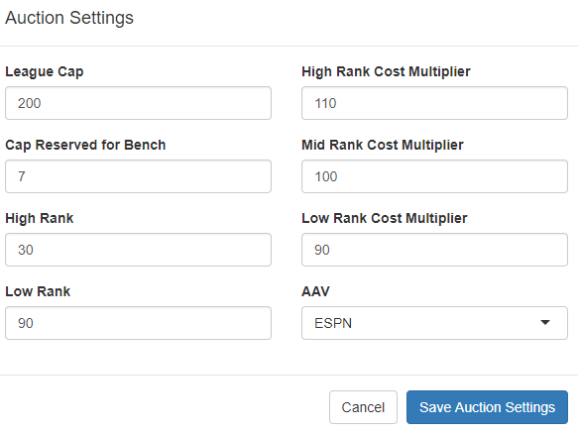

1. Team names and draft order
   1. Type in names of teams in order that they draft or select players for auction. Also indicate which is your team.

**SECTION 2 – DRAFT PAGE**

1. The Draft page needs to have all the relevant information in one place that the user needs.
   1. Input needs to be grouped together
      1. Pick #, price (if applicable), player name, Team that gets the player (snake draft should automate this)
      2. Functional buttons
         1. All: Submit, Undo,
         2. Snake Only: AutoPick for USER (for mock drafts), Auto pick for Opponent, AutoPick based on ADP (Average Draft position), Update for User (determines who the optimal picks are), Update for Opponent (Determines Opponents optimal picks)
         3. Auction Only: Update (Determines Max Bid for the current player up for bid), Update for each opponent (Shows the value of the player up for bid to a specific opponent)
      3. Metrics:
         1. Snake:
            1. Pick Value – Pick Position differential from actual value
            2. Projected Team points - Points for potential optimal lineup
            3. Best Player at each position by 1) ADP, 2) VOR, 3) Highest Ceiling (For Bench)
            4. Suggested Pick
            5. Projected next 3 picks, or more
         2. Auction:
            1. Highest VOR, by position
            2. $’s Saved – How much you spent vs. How much player is worth
            3. % Saved – Same as above, but a % value
            4. Actual spent
            5. Actual Value
            6. Players Ranked by most over/underbid, together & by position
            7. Highest Ceiling, by position
            8. AAV
            9. Max Bid, Original Value, Current Value – for all teams

Auction Design1:

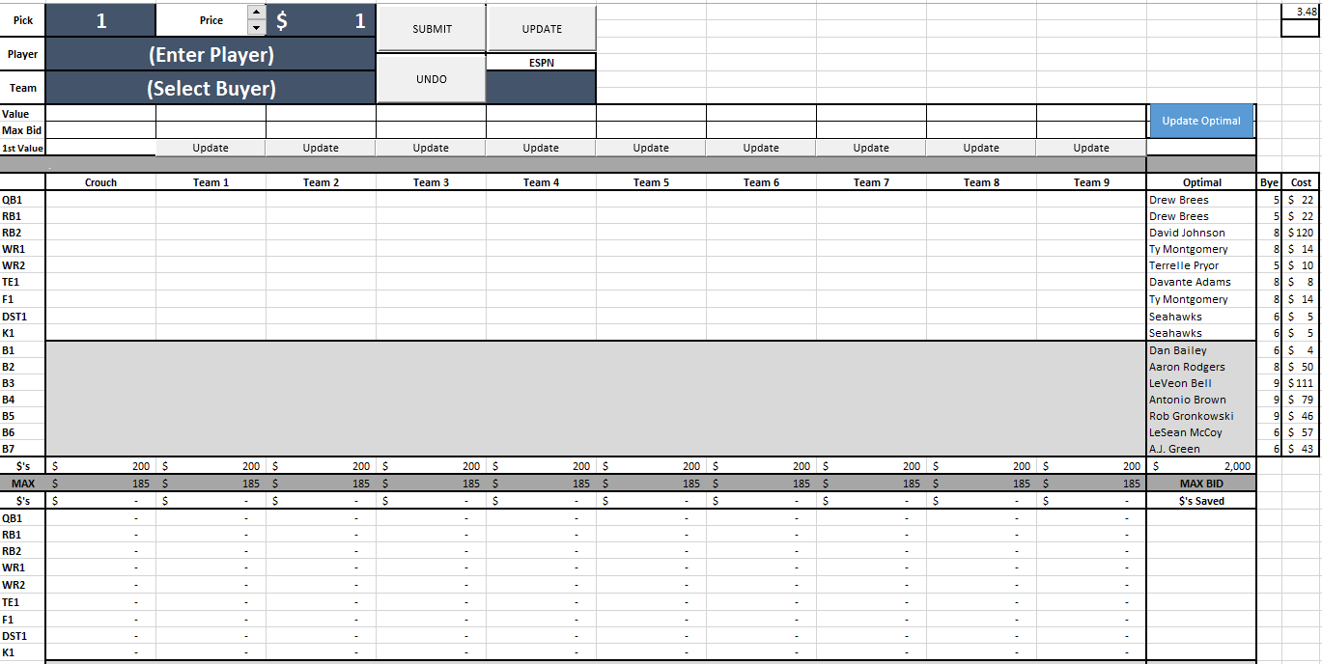

Snake Design:

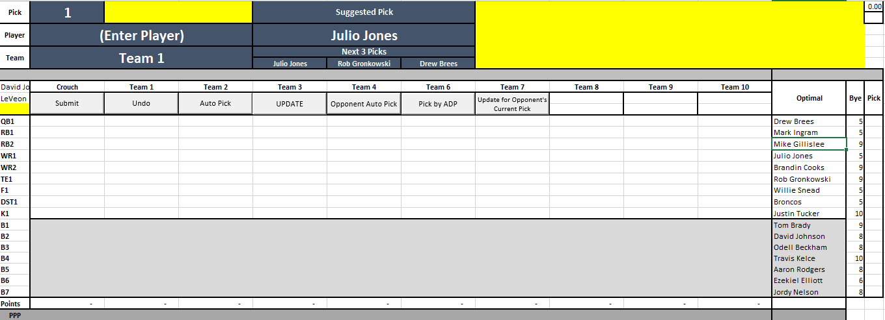

After all picks are in we can include something that shows how your team performs vs. how the optimal team would have performed.